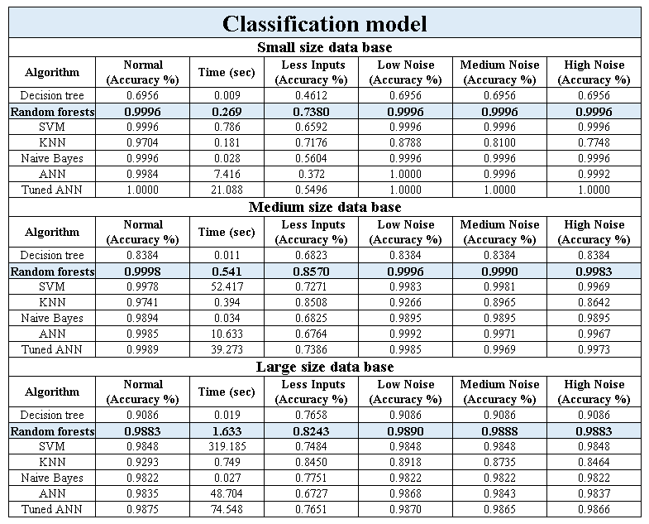

Table 4.Comparison of SML algorithms used to predict the type of geometrical fault using a classification model